**DineSys: Comprehensive Restaurant Management System for Seamless Dining Experience**

# Group Name:

**TEAM SE's**

# Group Members:

* **Vangala Ruchitha (Team Leader)**
* **Nikhila Polkampally**
* **Nandhini Kasukurthi**
* **Vishal Rachuri**
* **Sai Srinivas Valleti**
* **Chandralekha Gude**
* **Aishwarya Karukonda**
* **Hunny Keshwani**
* **Leela Varadatta Sai Addanki**

# Project Description:

The goal of this project is to develop a web-based application called RMS (Restaurant Management System) that will help simplify processes at a restaurant. Both customers and employees can use the app's two user interfaces. Table-based ordering, chef notifications, product management, HR, and distributor interactions are just some of the features. PHP, mySQL, JavaScript, and jQuery will be used for development.

RMS is a dynamic, web-based application tailored to revolutionize the restaurant industry. It simplifies operations and enhances the customer experience, catering to both the client and the staff's needs.

## For clients:

**Digital Ordering:** Each table is equipped with a tablet. Customers can browse through the interactive menu, place their orders, get real-time updates, and even opt to print the bill, all without waiting for a waiter. This eliminates possible order errors and streamlines the dining experience.

## For staff:

* **Kitchen Management:** Orders from the tablets directly reflect in the kitchen, where chefs can claim and prepare them. Progress updates get sent to the client's tablet.
* **Inventory Management:** As dishes get prepared, the application auto-updates the inventory. When stocks run low, the accountant gets notified to reorder.
* **Human Resources & Payroll:** Admins can add, modify, or remove staff details. Salary and attendance management is integrated, with the accountant managing salary disbursement.
* **Supplier Management:** The accountant can view and manage a list of product distributors, ensuring timely reorders to maintain restaurant operations.

Development Technologies: PHP, MySQL, JavaScript, and jQuery.

# Project Timeline - Initial Planning and Milestones:

Our timeline is broken down into key milestones:

|  |  |
| --- | --- |
| Week | Milestone |
| 1-2 | System Requirement Analysis |
| 3-4 | Design & Database Architecture |
| 5-6 | Initial Development Phase |
| 7-8 | Testing & Quality Assurance |
| 9-10 | Final Development & Feedback Incorporation |
| 11-12 | Deployment & User Training |

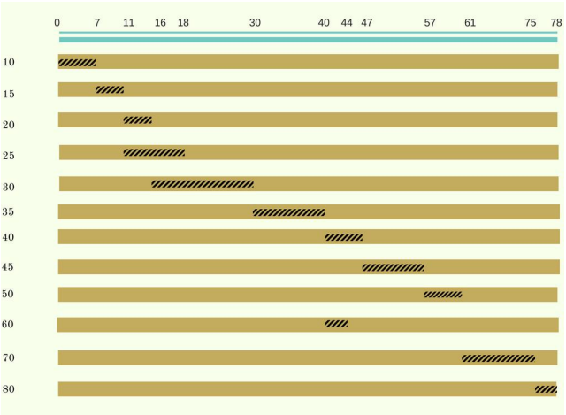

# Risk Management:

Top 3 risks identified:

## a. Software Bugs and Issues:

* Monitoring: Iterative testing and code reviews.
* Reevaluation: After reaching each significant goal.
* Contingency: Planning schedule padding for error analysis.

## b. Resource Unavailability:

* Monitoring: Verification of stock and personnel every week.
* Reevaluation: In-process evaluation.
* Contingency: Putting in place secondary sources of supply and cross-training employees.

## c. Changing Requirements:

* Monitoring: Frequent opportunities for client input and review.
* Reevaluation: After completing the Database Design and Architecture phase.
* Contingency: Maintaining a system's modularity facilitates change.

# Team Member Roles:

* Vangala Ruchitha: Team Leader, Client Interaction, and Requirement Gathering
* Nikhila Polkampally: Backend Developer and Database Manager
* Nandhini Kasukurthi: Frontend Developer and UI/UX Designer
* Vishal Rachuri: Tester and QA Specialist
* Sai Srinivas Valleti: System Analyst and Documentation Head
* Chandralekha Gude: Project Coordinator and Feedback Analyst
* Aishwarya Karukonda: Human Resources and Staff Training Coordinator
* Hunny Keshwani: Backend Developer, Tester
* Leela Varadatta Sai Addanki: Frontend Developer and UI/UX Assistant

**Member Contribution Table:**

|  |  |  |
| --- | --- | --- |
| Team Member | Role | Contribution |
| Vangala Ruchitha | Team Leader, Client Interaction | 13% |
| Nikhila Polkampally | Backend Developer, Database Manager | 12% |
| Nandhini Kasukurthi | Frontend Developer, UI/UX Designer | 12% |
| Vishal Rachuri | Tester, QA Specialist | 11% |
| Sai Srinivas Valleti | System Analyst, Documentation | 11% |
| Chandralekha Gude | Project Coordinator, Feedback Analyst | 11% |
| Aishwarya Karukonda | HR, Staff Training | 10% |
| Hunny Keshwani | Backend Developer | 10% |
| Leela Varadatta Sai Addanki | Frontend Developer, UI/UX Asst. | 10% |

**GitHub README:**

[Team-SE-s/Readme.txt at main · VangalaRuchitha/Team-SE-s (github.com)](https://github.com/VangalaRuchitha/Team-SE-s/blob/main/Readme.txt)

**GitHub Directory Structure:**

[VangalaRuchitha/Team-SE-s (github.com)](https://github.com/VangalaRuchitha/Team-SE-s/tree/main)

**Meeting Minutes:**

[Team-SE-s/Docs/Meeting-Minutes/Meeting1 at main · VangalaRuchitha/Team-SE-s (github.com)](https://github.com/VangalaRuchitha/Team-SE-s/blob/main/Docs/Meeting-Minutes/Meeting1)

**File Submissions:**

[Team-SE-s/Note-Deliverable-1.txt at main · VangalaRuchitha/Team-SE-s (github.com)](https://github.com/VangalaRuchitha/Team-SE-s/blob/main/Note-Deliverable-1.txt)